FCH8 -

Functionality
The system allows you to cancel a check and reverse a payment in a one transaction run. The check in question will be marked as void in the system, the payment document reversed and the invoices reopened for payment again.

Scenario
You have forgotten to block a check payment when processing the payment proposal, or if the wrong invoice was selected for the online check print.

Requirements
A posted check and a payment.

Menu Path | Accounting → Financial Accounting → Accounts Payable → Environment → Check information → Void → FCH8 - Cancel payment
Transaction Code | FCH8
1. Double click on FCH8 - Cancel payment.

Cancel Check Payment

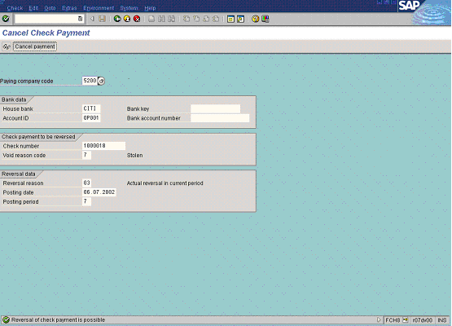

2. Update the following fields:

Field Name | Field Description | Values
Paying company code | The company code which processes the payment transactions | Example: 5200
House bank | Identification number for the house bank to which the transaction corresponds | Example: CITI
Account ID | Bank account ID | Example: OP001
Check number | The unique check number per company code, bank, and account number | Example: 1000018
Void reason code | Code identifying the reason for voiding a check number | Example: 07
Reversal reason | Reason for reversing a document. | Example: 03

3. Click Enter Button to confirm your entries.

4. Click Cancel payment Button to cancel the check payment.

5. The message bar displays “Payment for check XXXXX was cancelled, reverse document XXXXXXX”.

